dopey2 description, spin

This document is not ready.

This document covers methods used for visualizing and doing initial anlysis of data from Prodigy.

Data is loaded with the dopey.load() method.

Measurement types

The methods are compatible with spin EDC, MDC, and Map. Spin EDCs are reccorded with analyzer scan mode FixedAnalyzerTransmission, and MDCs and Maps are are reccorded with analyzer scan mode FixedEnergy. An EDC is reccorded with fixed deflector angles, a MDC is reccorded by scanning one deflector, and a Map is reccorded by scanning both deflectors. Arbitrary line scans, when stepping the deflectors together, are possible but not yet covered by the dopey.load() method.

Examples

EDC

data = dopey.load(spin_edc.xy)

Data type:
spin_edc
Data, axes, and parameters:
intensity counts/s shape=(8, 66)
axis0 Kinetic energy (eV) shape=(66,)
parameter0 NegativePolarity shape=(8,)

The .intensity is an array with, in this case, eight EDCs with each curve has 66 data points. .axis0 is the energy axis and .parameter0 contains the magnetisation polarity of the target for each curve.

Note: due to the unfortunate naming convention, NegativePolarity = -1 means what we refere to as positive polarity, which is pointing along $\hat{y}$ in the lab system for coil 1 and along $\hat{z}$ for coil 2.

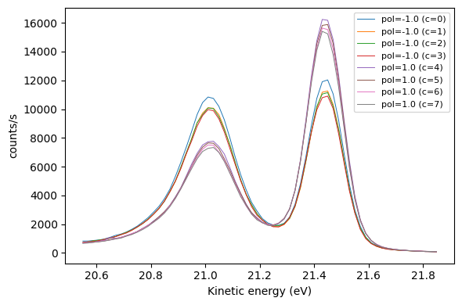

MDC

data = dopey.load(spin_mdc.xy)

Data type:
spin_mdc
Data, axes, and parameters:
intensity counts/s shape=(8, 43)
axis0 ShiftY [a.u.] shape=(43,)
parameter0 NegativePolarity shape=(8,)
parameter1 ShiftY [a.u.] shape=(43,)

The .intensity is an array with, in this case, eight MDCs with each curve has 43 data points. .axis0 is the deflector axis (in this case we deflect along $\hat{y}$) and .parameter0 contains the magnetisation polarity of the target for each curve. .parameter1 is the same as .axis0.

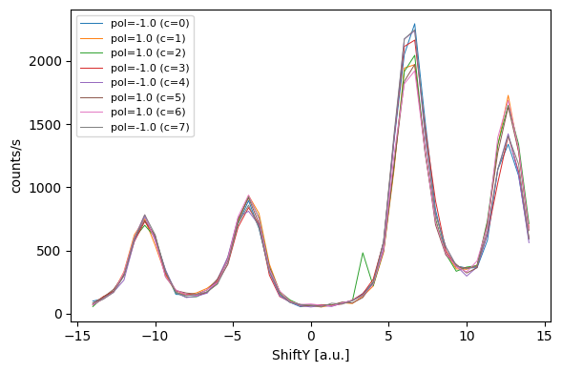

Map

data = dopey.load(spin_map.xy)

Data type:
spin_map
Data, axes, and parameters:
intensity counts/s shape=(8, 22, 20)
axis0 ShiftX [a.u.] shape=(22,)
axis1 ShiftY [a.u.] shape=(20,)
parameter0 NegativePolarity shape=(8,)

The .intensity is an array with, in this case, eight maps where each map is a 22×20 array ($\hat{x}×\hat{y}$). .axis0 and .axis1 are the deflector axes and .parameter0 contains the magnetisation polarity of the target for each map.

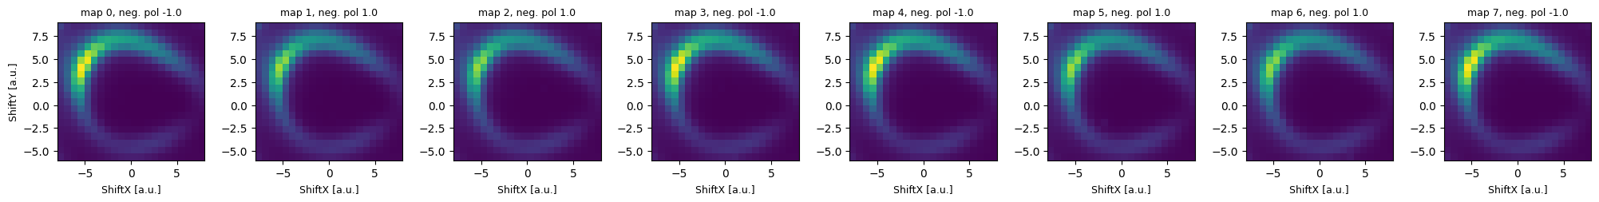

Methods

The following methods can be used for quick analysis of the spin data:

asymmetry(D = data, **kwargs)

polarization(**kwargs)

asymmetry()

Calculates the asymmetry, etc. and returns a new data object. For e.g. a spin EDC measurement the data object contains:

data = dopey.load(spin_edc.xy)
asym = asymmetry(data)
asym.arrays

Arrays:
intensity shape=(8, 66)
axis0 shape=(66,)
intensity_off shape=(66,)
intensity_on shape=(66,)
asymmetry shape=(66,)
component_plus shape=(66,)
component_minus shape=(66,)

The .intensity_off and .intenity_on arrays contain the mean intensities for the NegativePolarity = -1 and NegativePolarity = 1 respectivly, which are used to calculate the asymmetry in .asymmetry. The two arrays .component_plus and .component_minus is the distributed total intensity (generally refered to as component intensities).

Example:

To manipulate and analyze the data, first have a look at the curves:

_ = dopey.plot(data)



The first curve (c = 0) is an outlier and we ignore it by passing the attribute exclude (a list containing curves to exclude, in this case only 0) to the asymmetry() method. We also chose to normalize the intensities at the low kinetic energy side by passing normp and normpn. Passing normp = 0 and normpn = 5 means that each curve is normalized by the mean intensity of the 5 first points.

asym = asymmetry(data, exclude = [0], normp = 0, normpn = 5)

The result is plotted by passing various keyword arguments as True to the plot() method.

_ = dopey.plot(asym, asymmetry = True)

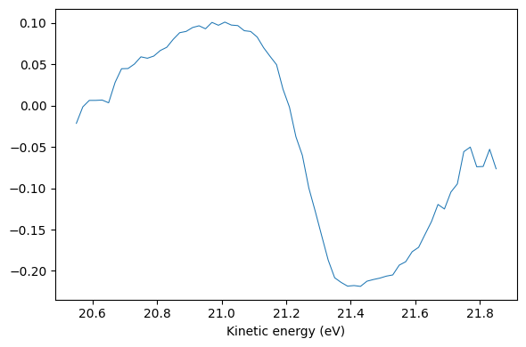

_ = dopey.plot(asym, component = True)

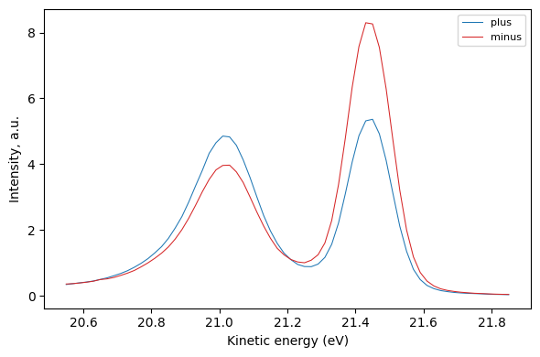

Manipulating and ananlyzing MDC and Map is done in the same or similar way.

